DDOS ATTACK DETECTION AND MITIGATION (REAL-TIME DDOS DETECTION AND ADAPTIVE MITIGATION FRAMEWORK USING MACHINE LEARNING)
Design and Implementation
Department of Computer Science and Engineering, [COLLEGE NAME]
Batch C15 (CSE-C) · Academic year [ACADEMIC YEAR]
Table 1: Project team
S.No. | Student name | Roll number
1 | Mallela Pallavi | 23K91A05E3
2 | Kattoju Durgabhavani | 24K95A0514
3 | Nimmala Rakshitha | 23K91A05H3
4 | Prodhatoor Shashi Preetham | 23K91A05K0

Project guide: V Meenakshi
Chapter and section numbers quoted in the text (for example Chapter 8 or Section 6.2) refer to the full project report, 17.Final Document. Figures and tables in this document are numbered from 1.

1. DESIGN
This chapter describes how SentinelFlow is built: the architecture and workflow, the data flow, the class, sequence and use-case design, the data design, the core algorithm, the module and API design and the user interface. Every diagram was drawn from the code in app.py, monitoring/, ml/, security/, database/ and frontend/src/; the complete set, each with a longer explanation, is also collected in the Block Diagrams document.
Three facts about the design are stated at the outset because they shape everything below. SentinelFlow is a single Python process with no message queue and no separate worker: the capture thread, the simulator thread, the health sampler and the Flask request threads share one set of in-memory objects. Its mitigation is application-level: a quarantine is an entry in a table inside the process, and the operating-system firewall is never touched. And its REST API has no authentication; the product relies on binding to 127.0.0.1. The design follows the detection half of the base paper [1] (a tree-based classifier on flow features) and adds the loop that paper lists as future work: severity assessment, mitigation, recovery and history.

1.1 Design Goals and Architecture
Five goals shaped the design. First, close the loop from a captured window to an action and back to a recovered state, so that detection is never the last step. Second, be explainable: every decision carries the factors that produced it, because a quarantined address must be justifiable to an administrator. Third, be safe by default: no attack traffic is generated, the firewall is not changed, local and loopback addresses are never quarantined, and quarantines expire by themselves. Fourth, run on a laptop without special hardware: the classifier is a Random Forest on ten numbers per window, and Simulation Mode needs neither Npcap nor Administrator rights. Fifth, use one pipeline for live and simulated traffic, so that the demonstration exercises the same code as a real capture.
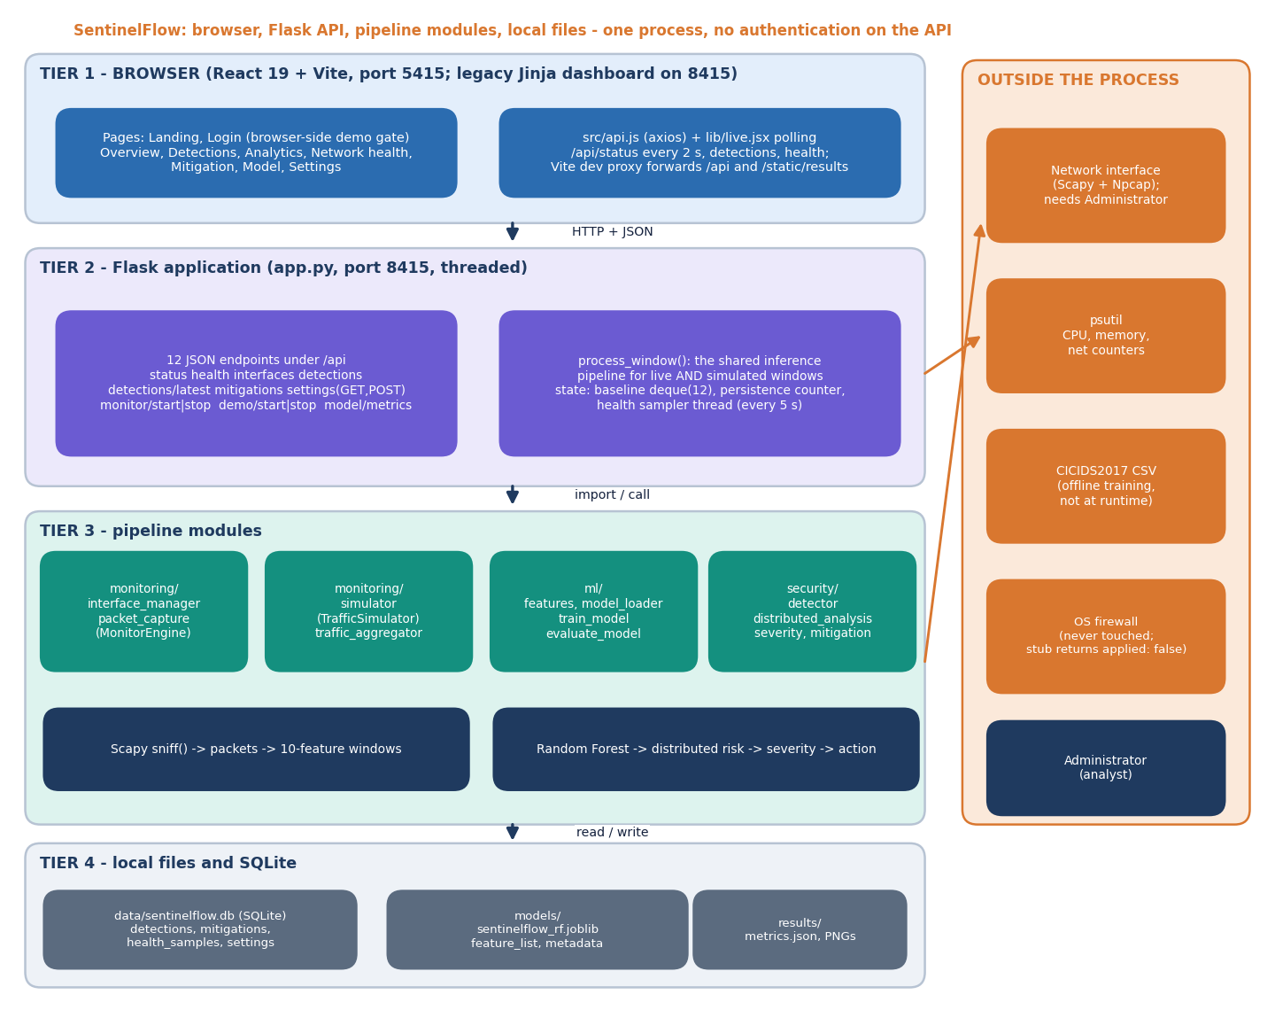
Figure 1: System architecture of SentinelFlow: browser tier, Flask API, pipeline modules and local files.
The architecture has four tiers. The browser tier is a React 19 single-page application served by Vite on port 5415; it polls the API every two seconds and holds no business logic. The Flask application listens on 127.0.0.1:8415, exposes twelve JSON endpoints and owns process_window(), the one function through which every window passes. The pipeline modules are plain Python packages: monitoring/ produces windows, ml/ defines the feature schema and loads the model, and security/ turns a prediction into a risk score, a severity and an action. State lives in a SQLite file and in the joblib, JSON and PNG artefacts written by training. Beyond the process boundary are the network interface (reached through Scapy), psutil for host counters and, at training time only, the CICIDS2017 files.

1.2 High-Level Workflow
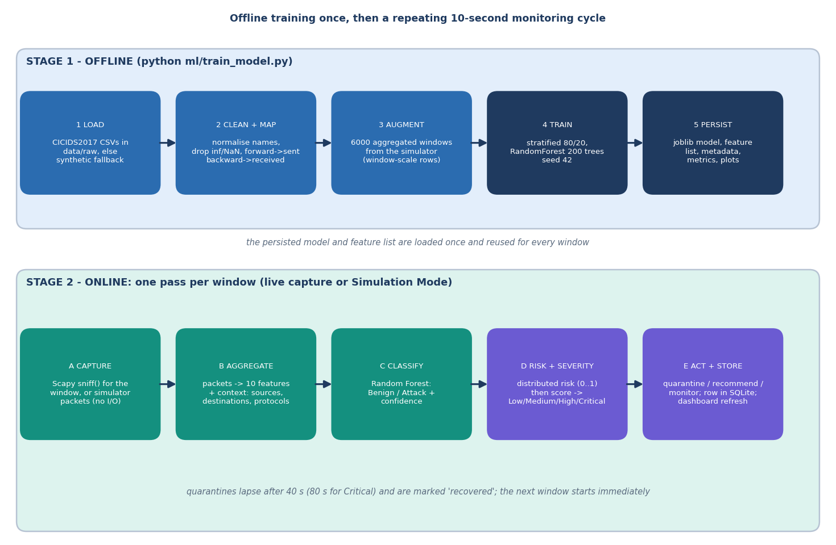
Figure 2: High-level workflow: offline training once, then a repeating capture, aggregate, classify, assess and act cycle.
The workflow has two time scales. Training is a command-line program, python ml/train_model.py, which took 22.2 seconds for the shipped model; it writes the model, the feature list, the metadata and the evaluation plots. Monitoring is a loop that repeats once per window. In live mode the window is the capture time of a Scapy sniff() call (ten seconds by default, two to 120 allowed); in Simulation Mode the simulator builds a packet list in memory and waits for the window length. Everything after the packet list is identical: aggregate, classify, assess, act, store.

1.3 Data Flow Diagrams

1.3.1 Level 0: context
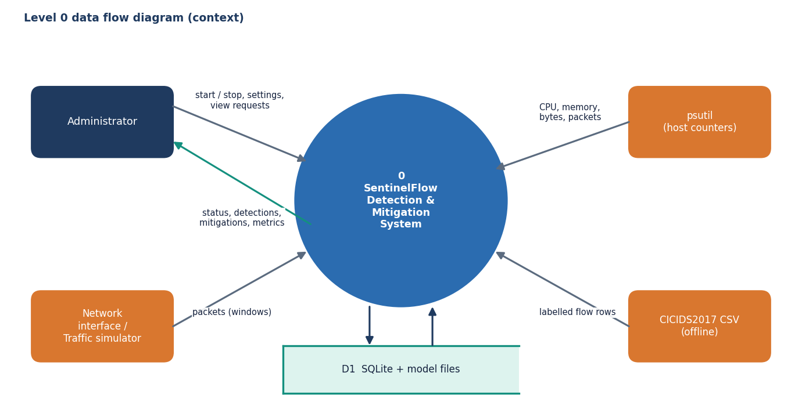
Figure 3: Level 0 data flow diagram: SentinelFlow and its four external entities.
At level 0 the system has four neighbours. The administrator controls sessions and reads results; the network interface or the simulator supplies packets; psutil supplies host counters for the health screen; the CICIDS2017 files supply labelled flow rows to the offline training script. A single store, D1, stands for the SQLite database and the model files.

1.3.2 Level 1: seven processes
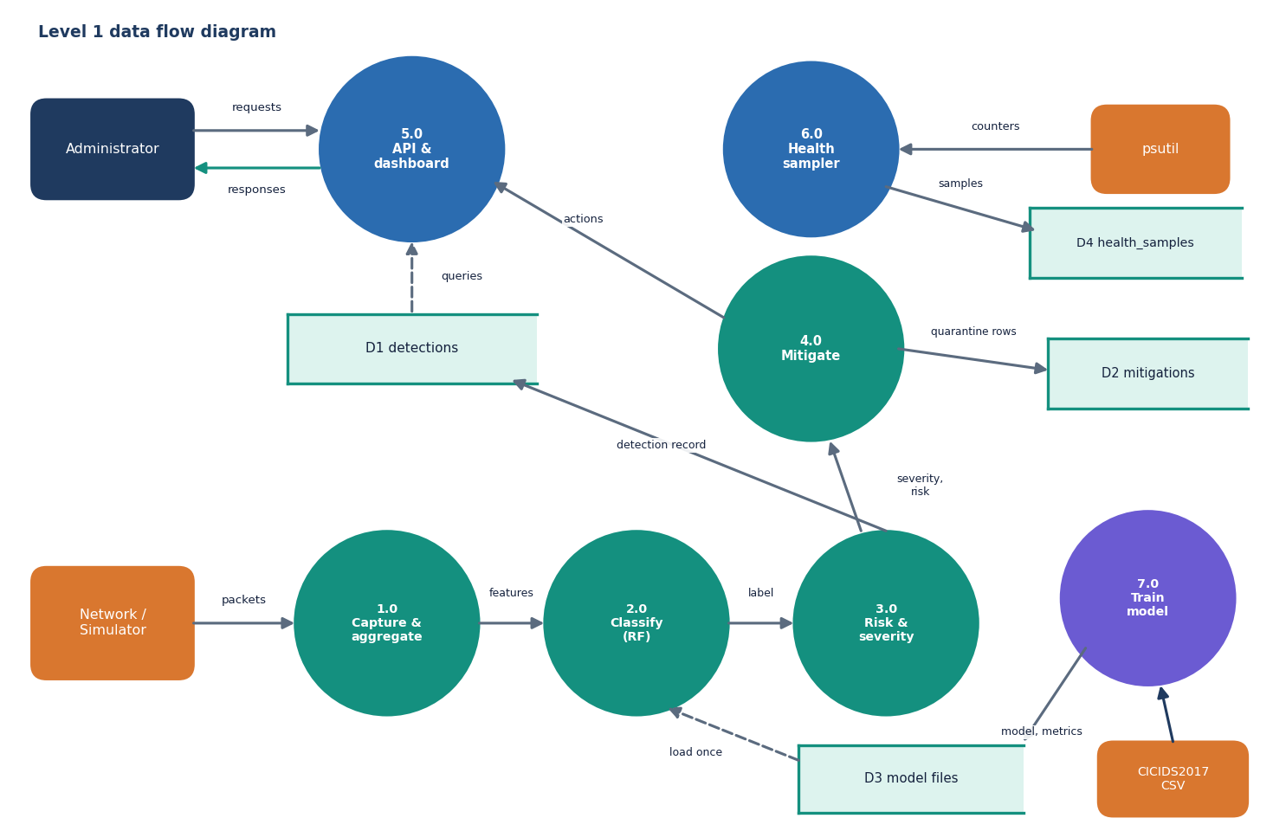
Figure 4: Level 1 data flow diagram: seven processes and four data stores.
Processes 1.0 to 4.0 run once per window. Process 2.0 loads the model files from D3 once and reuses them. Process 5.0, the API and dashboard, only reads: it answers the administrator's polls from D1 and D2. Process 6.0 is independent of traffic: a background thread samples CPU, memory and network counters every five seconds into D4. Process 7.0 is the offline trainer and is the only process that writes D3.

1.3.3 Level 2: risk, severity and mitigation
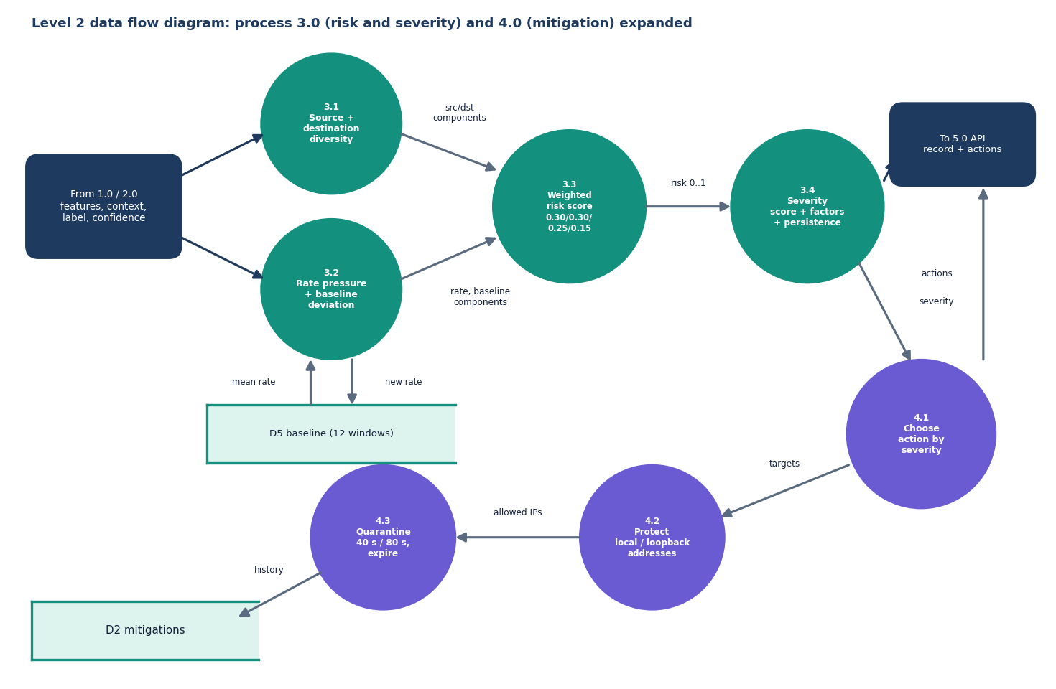
Figure 5: Level 2 data flow diagram: processes 3.0 (risk and severity) and 4.0 (mitigation) expanded.
Process 3.0 combines four measurable components into a distributed-risk score and then adds the forest's label, its confidence, the packet rate, the spread and the persistence of suspicious windows into a severity score, keeping a list of the factors that contributed. Process 4.0 maps the severity to an action. Only High and Critical produce quarantines; the targets are the three busiest sources, minus the protected addresses. The rolling baseline D5 holds the packet rates of the last twelve windows and feeds the deviation component of the next window.

1.4 Class, Sequence and Use-Case Design

1.4.1 Class diagram
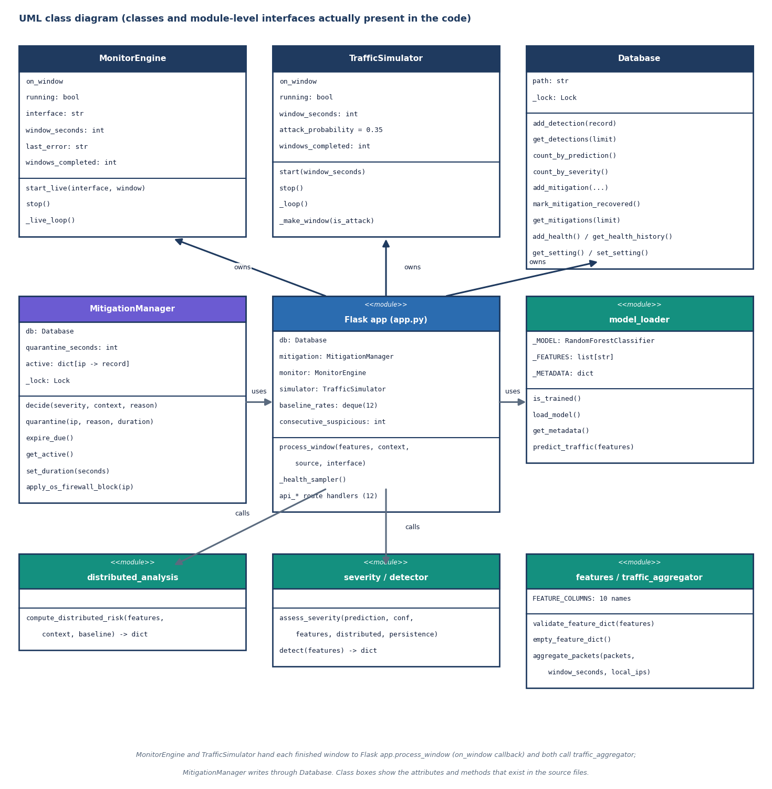
Figure 6: UML class diagram of the classes and module-level interfaces present in the code.
The design deliberately has few classes. MonitorEngine and TrafficSimulator are the two window producers and share one callback signature, on_window(features, context, source, interface). Database serialises every SQLite call behind a lock because Flask runs threaded. MitigationManager keeps the active quarantines in a dictionary keyed by address and writes history through Database. Everything else is a module of functions, which keeps the risk, severity and aggregation rules easy to test: the test-suite calls them directly with hand-made inputs.

1.4.2 Sequence diagram
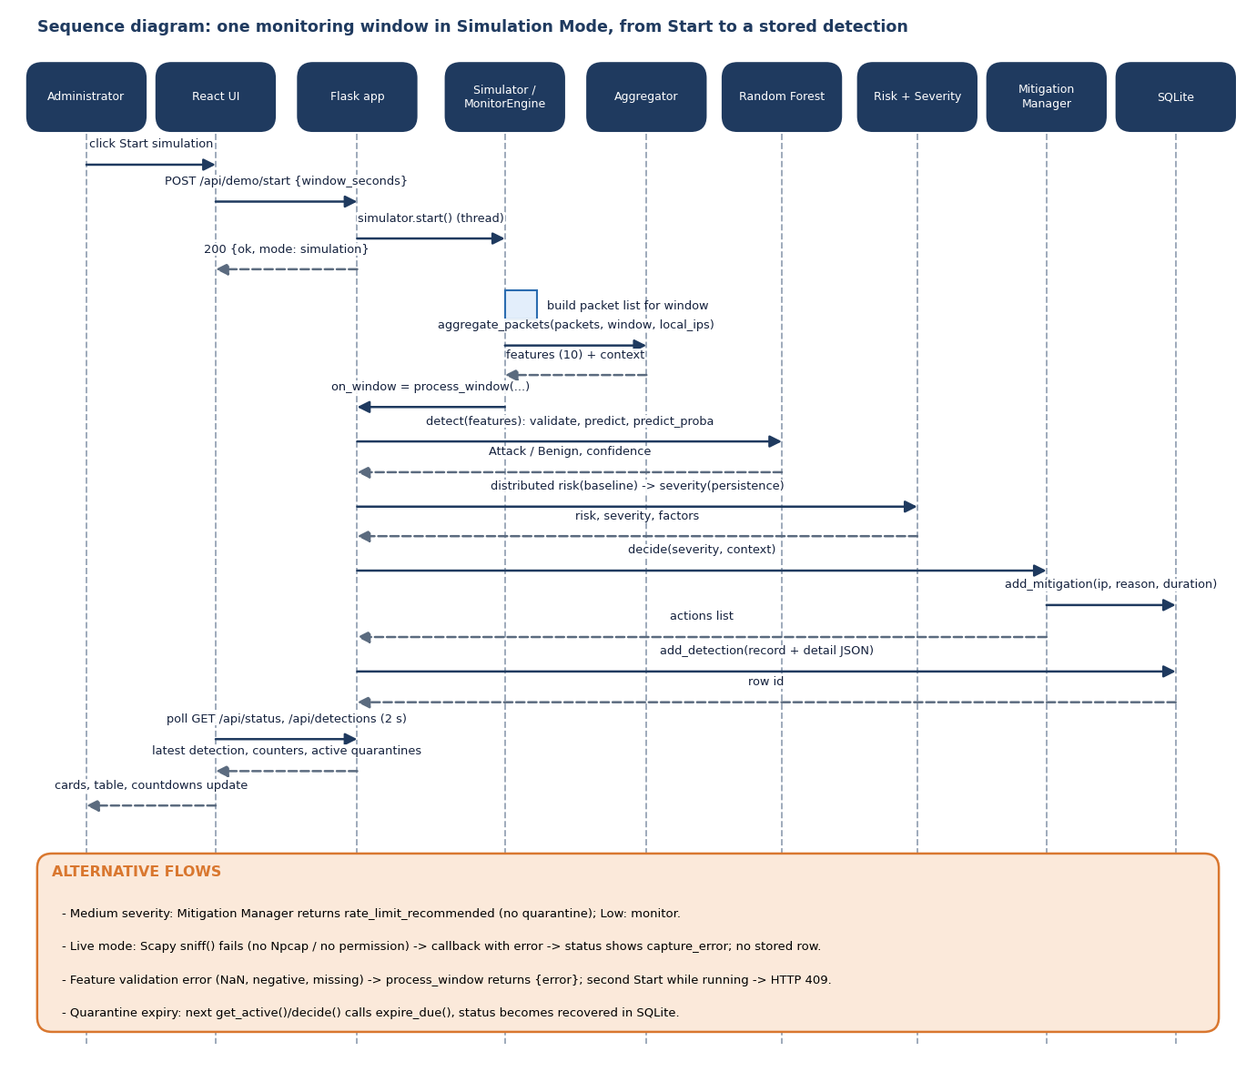
Figure 7: Sequence diagram: one monitoring window in Simulation Mode, from pressing Start to a stored detection.
The sequence shows why the console never waits for a detection: the Start request returns as soon as the simulator thread exists, and the console learns about new windows by polling. The alternative flows listed under the diagram are the ones covered by tests: a failing live capture, a validation error, a second Start (HTTP 409) and quarantine expiry.

1.4.3 Use-case diagram
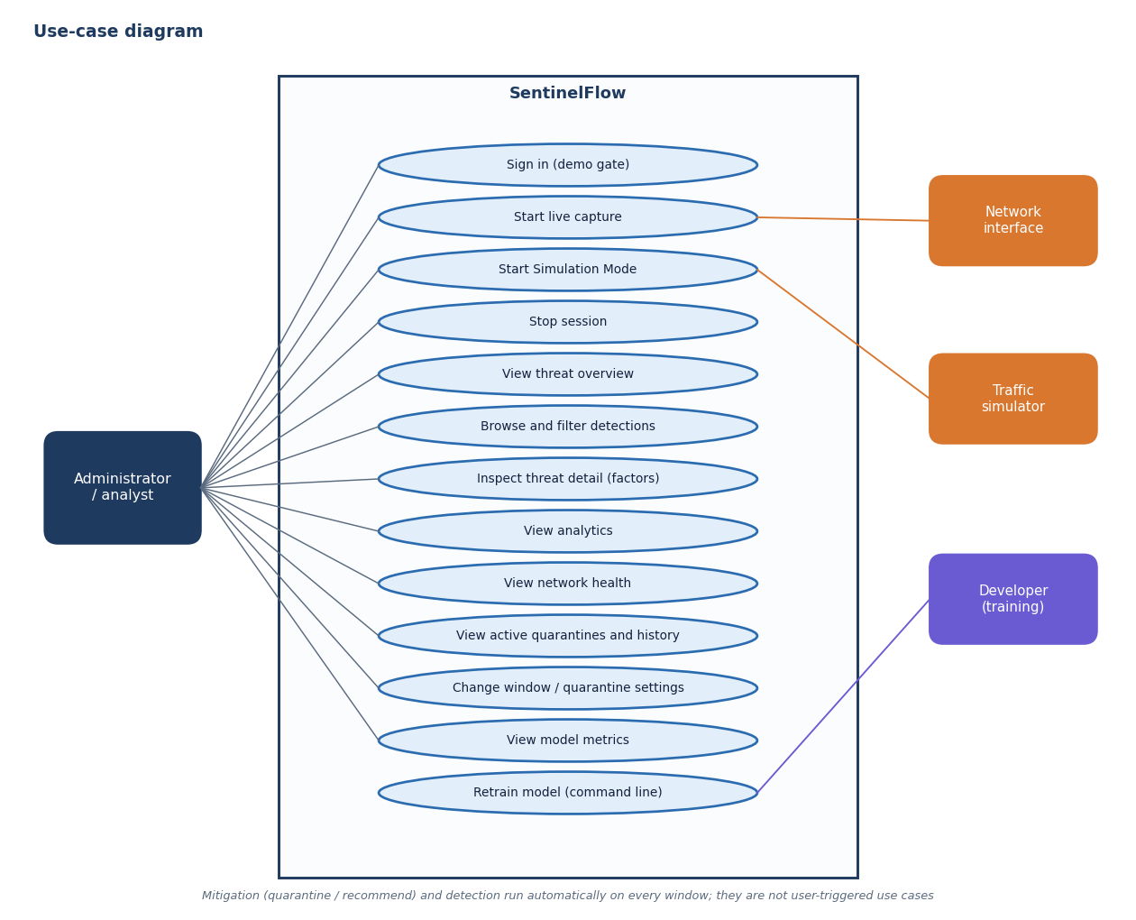
Figure 8: Use-case diagram: what the administrator and the external actors can do.
The administrator is the only human actor. Detection and mitigation are not use cases because nobody triggers them: they run on every window. Retraining the model is a developer use case performed from the command line, not from the console.

1.5 Data Design
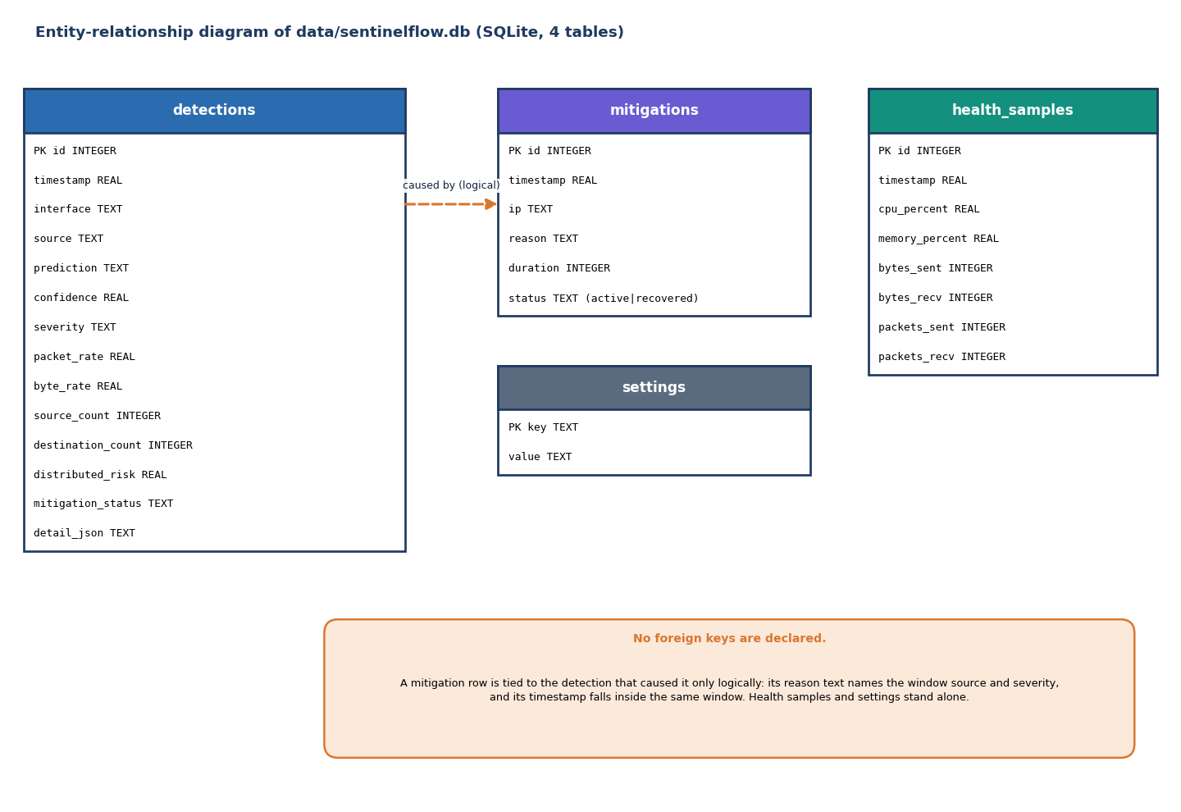
Figure 9: Entity-relationship diagram of the SQLite database: four tables and no declared foreign keys.
The database is one SQLite file, data/sentinelflow.db, created on first start by Database.__init__. Four tables are used; the data dictionary below describes them. There are no foreign keys: a quarantine row names the address, the reason text (which contains the window source and the severity) and the time, not the id of the detection that caused it. The full per-window detail (the ten features, the context, the risk components, the severity factors and the actions) is stored as one JSON text in detections.detail_json, so the Threat Detail screen can explain a past window exactly as it was scored.
Table 2: Data dictionary of the four tables
Table | Columns | Purpose and notes
detections | id (PK), timestamp, interface, source, prediction, confidence, severity, packet_rate, byte_rate, source_count, destination_count, distributed_risk, mitigation_status, detail_json | One row per scored window. prediction is Benign or Attack; severity is Low, Medium, High or Critical; source is live or simulation.
mitigations | id (PK), timestamp, ip, reason, duration, status | One row per quarantine. status is active until expiry, then recovered (updated by address and reason).
health_samples | id (PK), timestamp, cpu_percent, memory_percent, bytes_sent, bytes_recv, packets_sent, packets_recv | psutil sample every five seconds; the Network health screen reads the last 30.
settings | key (PK), value | Key-value table with get and set methods; the API currently keeps the window and quarantine settings in memory, so this table is unused.

Three further stores are files: models/sentinelflow_rf.joblib with feature_list.json and metadata.json (written by training, read once by model_loader), and results/ with metrics.json, confusion_matrix.json, feature_importance.json, classification_report.txt and three PNG plots (read by /api/model/metrics and /static/results/<file>). data/processed/test_features.csv keeps the held-out test rows.

1.6 Core Algorithm Design

1.6.1 The per-window algorithm
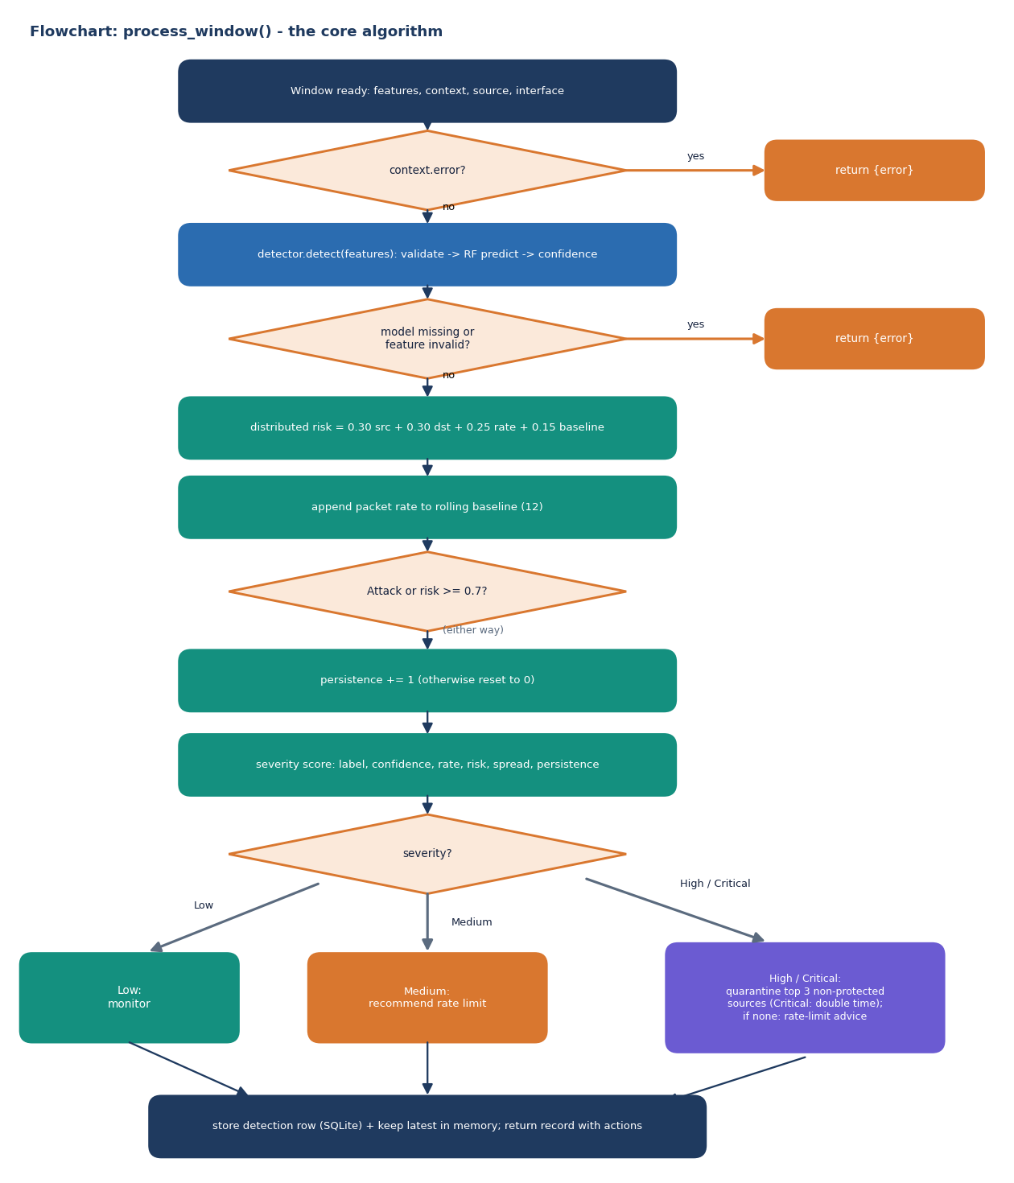
Figure 10: Flowchart of process_window(), the algorithm every window passes through.
process_window() is the heart of the application. It is deliberately a straight line with two early exits. The first exit handles a capture failure reported by the live engine (the context carries an error key); the second handles a missing model or invalid features, which ml.features.validate_feature_dict rejects when a value is missing, non-numeric, NaN, infinite or negative. After that the steps are fixed: distributed risk, baseline update, persistence update, severity, action, storage.

1.6.2 Distributed-risk and severity design
The distributed-risk layer exists because of carpet-bombing: traffic spread over many destinations can look modest at every single destination while the aggregate is large. Its four components are source diversity (distinct sources divided by 30, capped at 1), destination diversity (distinct destinations divided by 15, capped at 1), rate pressure (packets per second divided by 1,500, capped at 1) and baseline deviation (how far the packet rate is above the mean of the last twelve windows, scaled to 0 to 1 over a fourfold rise). The weights are 0.30, 0.30, 0.25 and 0.15. Scores below 0.4 are Low, below 0.7 Medium and otherwise High, and the sentence that goes with the score names the pattern: concentrated, spread across many sources, spread across many destinations (possible carpet bombing) or both.
Severity adds up points from independent evidence, so that no single signal decides. The label contributes most, the others refine it, and a benign label is capped so that a benign window can never rise above Medium.
Table 3: Severity points (security/severity.py)
Evidence | Condition | Points
Forest label | Attack / Benign | +30 / +8 x confidence
Model confidence | >= 0.90 / >= 0.75 | +15 / +8
Packet rate | >= 3,000 / >= 1,200 / >= 400 packets per second | +20 / +12 / +5
Distributed risk | >= 0.70 / >= 0.40 | +20 / +10
Spread | >= 25 sources or >= 12 destinations | +8
Persistence | >= 3 consecutive suspicious windows / exactly 2 | +10 / +5
Cap and levels | Benign capped at 45; Critical >= 70, High >= 50, Medium >= 28, otherwise Low | -

1.6.3 Mitigation policy
The policy is a table, not a model. Low keeps monitoring. Medium records a rate-limit recommendation for the interface. High quarantines the three busiest sources of the window for the configured time (40 seconds by default); Critical does the same for twice as long. Addresses that are unknown, loopback (127.0.0.1, ::1), the simulator's local host 192.168.1.20 or any address of a local interface are protected and never quarantined; when all top sources are protected the action degrades to a rate-limit recommendation. A source that is already quarantined is not quarantined again until the entry expires, and every call first expires due entries and marks them recovered in the history. The design choice that matters is what a quarantine is: an entry in MitigationManager.active and a row in mitigations. It is shown on the Mitigation screen and counted in the status, but no packet is dropped; an optional operating-system integration exists only as a stub, apply_os_firewall_block(), which returns applied: false.

1.7 Module Design
The table below lists every source module with its size and responsibility, so that the chapters that follow can refer to a module by name.
Table 4: Modules of SentinelFlow (line counts measured)
Module | Lines | Responsibility and key functions
app.py | 389 | Flask app; process_window, _health_sampler, 12 JSON routes, / page and /static/results/<file>; JSON 404 and 500 handlers
config/config.py | 33 | Host and port from .env (defaults 127.0.0.1:5000, set to 8415), window 10 s, baseline 12, quarantine 40 s, paths, seed 42, test size 0.2
ml/features.py | 62 | FEATURE_COLUMNS (ten names, fixed order), validate_feature_dict, empty_feature_dict
ml/preprocessing.py | 144 | normalize_columns, clean_dataframe, normalize_label_value, extract_label_series, map_to_common_schema (forward to sent, backward to received)
ml/train_model.py | 389 | Dataset lookup, synthetic fallback, window augmentation, 80/20 split, Random Forest, metrics, plots, artefacts
ml/model_loader.py | 87 | is_trained, load_model, get_metadata, predict_traffic (label, confidence)
ml/evaluate_model.py | 54 | Reloads the stored model and re-scores data/processed/test_features.csv
monitoring/interface_manager.py | 60 | list_interfaces (psutil + Scapy), local_ip_set
monitoring/packet_capture.py | 121 | MonitorEngine: rolling Scapy sniff() windows, error classification (permission, interface, Npcap)
monitoring/simulator.py | 98 | TrafficSimulator: benign, flood, carpet and slow windows, no network I/O
monitoring/traffic_aggregator.py | 83 | aggregate_packets: ten features plus context (sources, destinations, protocol shares, top sources)
security/detector.py | 9 | detect: refuses to run without a trained model
security/distributed_analysis.py | 73 | compute_distributed_risk
security/severity.py | 78 | assess_severity
security/mitigation.py | 115 | MitigationManager: decide, quarantine, expire_due, get_active, set_duration
database/db.py | 204 | Database: four tables, locked SQLite access

The front end adds about 3,100 lines of JSX and JavaScript in frontend/src/: ten page components, a small UI kit (table, charts, controls, command palette, activity log), an api.js axios client, a polling provider (lib/live.jsx), a demo-login provider (lib/auth.jsx) and a theme provider.

1.8 API Design
The API is JSON over HTTP on 127.0.0.1:8415. Errors are JSON objects with an error key and a meaningful status: 400 for invalid input, 404 for unknown routes, 409 when a session is already running, 500 for failures. The table below lists the twelve endpoints and the two additional routes.
Table 5: Routes of app.py
Method | Path | Purpose | Notable behaviour
GET | /api/status | Mode, window, windows completed, latest detection, active mitigations | mode is stopped, live or simulation; capture_error carries the last capture failure
GET | /api/health | Current host sample, last 30 recent, last 30 from SQLite | -
GET | /api/interfaces | Interface names, addresses, up/down | 500 if discovery fails
GET | /api/detections?limit= | Stored detections with counts by prediction and severity | limit clamped to 1-500; non-integer gives 400
GET | /api/detections/latest | Most recent detection | Falls back to SQLite; message when none
GET | /api/mitigations | Active quarantines with seconds left, history (100), quarantine length | Expires due entries first
GET / POST | /api/settings | Window (2-120 s), quarantine (5-3600 s), interface | Out-of-range or non-numeric gives 400; malformed JSON is tolerated
POST | /api/monitor/start | Start live capture on an interface | 409 if a session runs; capture failure is reported through status
POST | /api/monitor/stop | Stop live capture | Idempotent
POST | /api/demo/start | Start Simulation Mode (window 2-120 s, default 5) | 409 if a session runs
POST | /api/demo/stop | Stop simulation | Idempotent
GET | /api/model/metrics | metrics.json, feature importance, confusion matrix | trained: false and a message when no model exists
GET | / | Original server-rendered dashboard | Jinja template
GET | /static/results/<file> | Evaluation PNGs from results/ | send_from_directory; path traversal returns 404

1.9 User Interface Design
The console is a React single-page application in a dark, monospace-accented style with a light theme on a toggle. The landing page explains the pipeline and shows live counters from /api/status; the demo login gate leads to the console, which has a sidebar with seven screens (Overview, Detections, Analytics, Network health, Mitigation, Model, Settings), a top bar with a search box, a mode pill and a theme toggle, and a command palette (opened with /) with g-then-letter shortcuts.
Table 6: Console screens and the data each reads
Screen | Content | Source
Overview | Session control (interface, window, Start live, Start simulation, Stop); six cards: threat status, severity with risk, model confidence, packets per second, sources and destinations, active mitigations; packet-rate sparkline; latest windows | /api/status, /api/detections, /api/interfaces
Detections | Filterable, sortable table of every scored window; click opens the Threat Detail drawer with measured traffic, risk components, severity factors and the recommendation | /api/detections
Analytics | Benign-versus-attack donut, severity distribution, packet-rate and confidence timeline | /api/detections
Network health | CPU, memory, bytes and packets in and out with time series | /api/health
Mitigation | Active quarantines with countdown bars, history, quarantine length | /api/mitigations
Model | Accuracy, precision, recall, F1, ROC-AUC, confusion matrix, feature importance, plots, and a synthetic-data warning | /api/model/metrics
Settings | Window and quarantine length, with server-side validation messages | /api/settings

Three design choices are worth stating. Simulation Mode is always labelled: a pill in the top bar and a banner on the Overview screen say that nothing shown is live traffic. Failures are shown, not hidden: when live capture cannot start, the real reason from Scapy appears in a banner (the Overview capture in Chapter 8 shows the Npcap message). The Model screen warns when the training data were synthetic, which is the case for the shipped model. The output screens are shown and discussed in Chapter 8.

1.10 Design Trade-offs and Known Weaknesses
• One process, shared memory. Simple and fast, but the quarantine table and the baseline are lost on restart (history survives in SQLite) and the design does not scale beyond one host.
• Application-level mitigation. Safe and demonstrable on any machine, but it does not stop a single packet; turning it into enforcement needs a firewall or SDN rule installer and a very careful allow-list.
• Rules around a classifier. The risk and severity weights are hand-set and not learned; they are transparent, and Chapter 8 measures what they achieve, but they were not tuned on real attack captures.
• Window length is a hidden parameter. The forest was calibrated on 10-second windows; at 2 and 5 seconds its label alone raises 46 % and 14 % false alarms on benign windows, and the severity layer is what keeps the quarantine rate low (6.8 % and 0.27 %).
• No authentication on the API. Acceptable for a localhost-only prototype; the demo login is a browser-side gate and protects nothing.
• Saved forest uses all cores. The model was stored with n_jobs=-1, which makes single-window inference about ten times slower than a single thread (Chapter 7).

2. IMPLEMENTATION

2.1 Application Architecture
The application is Flask 3 serving on 127.0.0.1:8415 with threaded=True, debug=False and no reloader. app.py creates one Database, one MitigationManager, one MonitorEngine and one TrafficSimulator at import time and wires both producers to process_window. A daemon thread, _health_sampler, appends a psutil sample to a 120-entry in-memory deque and to SQLite every five seconds; failures are printed and the next sample is attempted. Shared mutable state (the latest detection, the persistence counter, the health buffer) is guarded by state_lock; the rolling baseline is a deque(maxlen=12) of packet rates. The React console is a separate Vite project in frontend/ (React 19, React Router 7, axios, Recharts, Tailwind 4, three.js for the landing background) served on port 5415, whose dev server proxies /api and /static/results to the API so that the browser makes only same-origin calls.
process_window(features, context, source, interface) is the single entry point for both producers. It returns an error record when the context carries a capture error, when the model is missing or when feature validation fails; otherwise it computes the distributed risk, updates the baseline and persistence, assesses severity, asks the mitigation manager for actions and stores a detection record. If the database write fails the record is still kept in memory with id = None, so the console keeps working. Appendix A quotes the function.

2.1.1 Window producers
MonitorEngine._live_loop repeats sniff(iface, prn=callback, timeout=window, store=False); the callback extracts source, destination, protocol and length from IPv4 or IPv6 packets and skips malformed ones. A PermissionError produces a message about Administrator rights and Npcap; messages mentioning an unknown device or interface produce an invalid-interface message; Npcap or WinPcap problems produce the driver message; anything else is reported with the interface name. After an error the engine posts one error window (so the status can show it), stops itself and leaves it to the user to retry or switch to Simulation Mode. TrafficSimulator chooses benign or attack windows with attack probability 0.35 and builds packet lists in memory: benign windows of 60 to 600 packets between 192.168.1.20 and three external hosts; flood windows of 2,500 to 9,000 packets from 8 to 40 sources to one victim; carpet windows of 1,800 to 6,000 packets from 10 to 45 sources to 6 to 20 destinations; slow windows of 300 to 1,200 TCP packets from many sources to one victim. No packet is sent anywhere.
Table 7: Traffic styles produced by the simulator (monitoring/simulator.py)
Style | Packets per window | Sources | Destinations | Protocols and sizes
Benign | 60-600 | 2 external hosts and 1 local host | 3 external hosts and the local host | TCP 62 %, UDP 28 %, ICMP 4 %, other 6 %; mixed sizes up to 1,200 bytes; both directions
Flood | 2,500-9,000 | 8-40 sources | 1 victim | TCP 55 %, UDP 35 %, ICMP 10 %; 60-320 bytes; one direction
Carpet bombing | 1,800-6,000 | 10-45 sources | 6-20 victims | TCP 50 %, UDP 50 %; 60-520 bytes
Slow | 300-1,200 | up to ~4,000 possible addresses, many distinct | 1 victim | TCP only; 200-1,400 bytes

The styles are the pattern classes the product aims at: a volumetric flood from many sources to one victim, carpet bombing from many sources across many victims, and a slow attack with modest volume. They are generated by the same code that produced the 6,000 window rows used in training, which means that high accuracy on simulator windows at the training window length is expected and proves nothing about real attacks; Chapter 8 says so wherever those numbers appear.

2.1.2 Pseudocode of the two loops
TRAINING (ml/train_model.py)
rows <- CICIDS2017 CSVs in data/raw, else synthetic fallback (9,000 + 9,000 flows)
X, y <- map_to_common_schema(clean(rows)), label BENIGN -> 0, anything else -> 1
X, y <- X + 3,000 benign windows + 3,000 attack windows (simulator generator, 10 s)
split <- stratified 80 / 20, seed 42
forest <- RandomForest(200 trees, balanced).fit(train); write metrics, plots, model

MONITORING (one iteration per window)
packets <- sniff(window) or simulator.make_window()
features, context <- aggregate_packets(packets, window, local_ips)
label, conf <- forest(features) # validate first
risk <- distributed_risk(features, context, baseline)
persistence <- persistence + 1 if label == Attack or risk >= 0.7 else 0
level, factors <- severity(label, conf, features, risk, persistence)
actions <- policy(level, context.top_sources) # quarantine / recommend / monitor
store(detection, actions); expire due quarantines

2.2 API Design
Twelve JSON endpoints, the legacy page and the results route are described in Chapter 5. The conventions are uniform: GET endpoints are read-only and cheap (median 3 to 13 ms over real HTTP except /api/interfaces at 36 ms, which asks the operating system for adapters); POST endpoints take a JSON body and tolerate a malformed or missing body by treating it as empty; every input is validated before use and rejected with HTTP 400 and an error message, and conflicts return 409. A global handler turns unknown routes into a JSON 404 and unhandled exceptions into a JSON 500.

2.3 Front-End Implementation
The front end has ten page components and a small kit of shared components. lib/live.jsx polls /api/status every two seconds and fetches detections and mitigations on a slower cadence, then shares the result through a React context, so every screen sees the same data; lib/auth.jsx implements the demo gate (credentials checked in the browser and a flag kept in localStorage); lib/theme.jsx keeps the light or dark choice; components/ui/CommandPalette.jsx and nav.jsx implement the keyboard shortcuts. Charts use Recharts; the landing page draws a three.js grid and a typewriter terminal, and respects the reduced-motion setting. The Threat Detail drawer renders the stored detail_json of a detection.

2.4 Security and Error Handling
Table 8: Security and error-handling measures, with what each was checked by
Concern | Measure in the code | Checked by
Network exposure | Flask binds to 127.0.0.1 only (config HOST); Docker image pins 0.0.0.0 inside the container only | Configuration review
Input validation | window 2-120, quarantine 5-3600, limit clamped 1-500; integers parsed with try/except; features validated for presence, numeric type, NaN, inf and negatives | Unit and API tests; 25 of 25 HTTP probes behaved as intended
Injection | All SQL uses parameter placeholders; a limit=1;DROP TABLE detections probe returns 400 | HTTP probe
Path traversal | Results files are served by send_from_directory; .. paths return 404 | HTTP probe
Safe mitigation | Quarantine is application-level; protected addresses (unknown, loopback, simulator host, local interface addresses) are never targeted; entries expire; OS firewall stub returns applied: false | Unit tests
Failure of capture | Real reason shown (permission, interface, Npcap); engine stops instead of looping | HTTP probe: HTTP 200 on start, then capture_error in status
Failure of storage or model | Corrupt or missing model gives a clear message; a failed detection write is caught; health-sampler errors are printed and skipped | Unit tests (model missing)
Concurrency | One lock in Database, one in MitigationManager, state_lock in the app; a second Start returns 409 | API tests

Three gaps are stated plainly. The REST API has no authentication; protection rests on the localhost binding and the demo login is a browser-side gate that protects nothing. The interface field of the settings call is not length-checked (a 5,000-character value was accepted and stored in memory). And the settings table is never used: settings are kept in memory and return to their defaults on restart.
Table 9: Error paths of live capture and what the user sees
Condition | Message shown (status.capture_error / banner) | State afterwards
Scapy cannot be imported | Scapy is unavailable: <reason> | Engine stopped
Permission denied | Packet capture permission denied ... Run as Administrator/root, install Npcap on Windows, or use Simulation Mode | Engine stopped after one error window
Unknown interface | Invalid network interface '<name>': <reason> | Engine stopped
Npcap or WinPcap missing (this machine) | Packet capture driver unavailable ... Install Npcap (https://npcap.com) or use Simulation Mode | Start returns HTTP 200, mode returns to stopped within seconds
Any other capture error | Capture failed on '<interface>': <reason> | Engine stopped
Aggregation or callback failure | Aggregation failed: <reason> / Detection callback failed: <reason> | Loop continues with the next window

2.5 Installation and Execution
Requirements are Windows 10 or 11 (or a modern Linux), Python 3.11 or 3.12, Node.js 20 or newer for the console and, for live capture only, Npcap and an Administrator terminal. run.bat creates .env with the default ports, creates .venv, installs requirements.txt, trains the model if it is missing, runs npm install on the first start, starts the API and the console and opens the browser. The demonstration login is demo@sentinelflow.com / Demo@1234; Simulation Mode needs no privileges. Appendix B gives the steps.

3. KEY CODE WALK-THROUGHS

3.1 The shared pipeline: process_window()
process_window() in app.py is the one function every window passes through, whether it came from Scapy or from the simulator. It returns an error record early if the capture engine reported a failure or if the feature vector is invalid, then computes the distributed risk against the rolling baseline, updates the persistence counter, asks severity.assess_severity() for a level, lets the mitigation manager decide, builds the record and stores it.
def process_window(features: dict, context: dict, source: str, interface: str) -> dict:
"""Shared inference pipeline for live and simulated windows."""
global consecutive_suspicious, latest_detection
if context.get("error"):
return {"error": context["error"]}
try:
ml_result = detector.detect(features)
except FileNotFoundError as exc:
return {"error": str(exc)}
except ValueError as exc:
return {"error": "Feature validation failed: %s" % exc}

packet_rate = float(features.get("received_packets_per_second", 0.0)) + float(
features.get("sent_packets_per_second", 0.0))
dist = distributed_analysis.compute_distributed_risk(features, context, _baseline())
baseline_rates.append(packet_rate)

with state_lock:
if ml_result["label"] == 1 or dist["distributed_risk_score"] >= 0.7:
consecutive_suspicious += 1
else:
consecutive_suspicious = 0
persistence = consecutive_suspicious

sev = severity.assess_severity(ml_result["prediction"], ml_result["confidence"],
features, dist, persistence)
actions = mitigation.decide(sev["severity"], context,
"SentinelFlow %s window (%s)" % (ml_result["prediction"], source))
mitigation_status = actions[0]["action"] if actions else "monitor"

record = {
"timestamp": time.time(),
"interface": interface,
"source": source,
"prediction": ml_result["prediction"],
"confidence": ml_result["confidence"],
"severity": sev["severity"],
"packet_rate": dist["packet_rate"],
"byte_rate": dist["byte_rate"],
"source_count": dist["unique_sources"],
"destination_count": dist["unique_destinations"],
"distributed_risk": dist["distributed_risk_score"],
"mitigation_status": mitigation_status,
"detail": {
"features": features,
"context": {k: v for k, v in context.items() if k != "simulated_attack_intended"},
"distributed": dist,
"severity": sev,
"actions": actions,
},
}
try:
record_id = db.add_detection(record)
record["id"] = record_id
except Exception:
record["id"] = None
with state_lock:
latest_detection = record
return record

Three details matter. The baseline is updated after the risk is computed, so a window is never compared with itself. The persistence counter counts consecutive windows that the forest calls Attack or whose risk is at least 0.7, and it resets to zero otherwise. A failure to store the row does not lose the verdict: the record is returned with id set to None.

3.2 Aggregating packets into the schema
aggregate_packets() turns a list of packet summaries into the ten features and a context dictionary. The orientation rule decides which direction a packet counts in: outbound from a local address is sent, everything else is received.
for pkt in packets:
try:
src = str(pkt.get("src", "unknown"))
dst = str(pkt.get("dst", "unknown"))
length = max(int(pkt.get("length", 0)), 0)
proto = str(pkt.get("proto", "other"))
except Exception:
continue
srcs.append(src)
dsts.append(dst)
protos.append(proto)
per_src[src] += 1
per_dst[dst] += 1
src_local = src in local_ips
dst_local = dst in local_ips
if src_local and not dst_local:
sent_packets += 1
sent_bytes += length
else:
# dst local, both local (loopback), or external transit
received_packets += 1
received_bytes += length

Malformed packet summaries are skipped, so one bad packet cannot abort a window. The same function serves live capture and the simulator, which is why both paths produce identical features for the same traffic.

3.3 Distributed-risk score
The score combines four components, each capped at 1: unique sources (30 saturates), unique destinations (15 saturates), packet rate (1,500 packets/s saturates) and the deviation of the packet rate from the rolling baseline. The weights are 0.30, 0.30, 0.25 and 0.15, and the explanation string names the pattern, including 'possible carpet-bombing pattern' when many destinations are seen.
# Component 1: source diversity (many distinct sources).
src_component = min(n_src / 30.0, 1.0)
# Component 2: destination diversity (carpet-bombing signal).
dst_component = min(n_dst / 15.0, 1.0)
# Component 3: absolute packet-rate pressure.
rate_component = min(packet_rate / 1500.0, 1.0)
# Component 4: deviation from rolling baseline.
if baseline and baseline.get("packet_rate", 0) > 1:
deviation = packet_rate / max(baseline["packet_rate"], 1.0)
baseline_component = min(max(deviation - 1.0, 0.0) / 4.0, 1.0)
else:
baseline_component = 0.0 if packet_rate < 300 else 0.4

score = round(
0.30 * src_component
+ 0.30 * dst_component
+ 0.25 * rate_component
+ 0.15 * baseline_component,
4,
)
if score >= 0.7:
level = "High"
elif score >= 0.4:
level = "Medium"
else:
level = "Low"

3.4 Severity score
Severity is an additive score with a reason attached to every addition. A Benign window can add at most a small residual and is capped at 45, so it can never be High or Critical. The thresholds are 28 (Medium), 50 (High) and 70 (Critical).
score = 0.0
factors = []

if is_attack:
score += 30
factors.append("Random Forest classified the window as Attack (%.1f%% confidence)" % (confidence * 100))
else:
factors.append("Random Forest classified the window as Benign (%.1f%% confidence)" % (confidence * 100))
score += 8 * confidence # small residual for uncertain benign windows

if confidence >= 0.9:
score += 15
factors.append("High model confidence (>= 90%)")
elif confidence >= 0.75:
score += 8
factors.append("Moderate model confidence (>= 75%)")

if packet_rate >= 3000:
score += 20
factors.append("Very high packet rate (%.0f pkt/s)" % packet_rate)
elif packet_rate >= 1200:
score += 12
factors.append("Elevated packet rate (%.0f pkt/s)" % packet_rate)
elif packet_rate >= 400:
score += 5
factors.append("Above-normal packet rate (%.0f pkt/s)" % packet_rate)

if risk >= 0.7:
score += 20
factors.append("High distributed-traffic risk (%.2f): %s" % (risk, distributed.get("explanation", "")))
elif risk >= 0.4:
score += 10
factors.append("Medium distributed-traffic risk (%.2f)" % risk)

if n_src >= 25 or n_dst >= 12:
score += 8
factors.append("Wide traffic spread (%d sources, %d destinations)" % (n_src, n_dst))

if persistence >= 3:
score += 10
factors.append("Persistent suspicious activity across %d consecutive windows" % persistence)
elif persistence == 2:
score += 5
factors.append("Repeated suspicious activity across 2 consecutive windows")

if not is_attack:
score = min(score, 45) # benign windows cannot exceed Medium

if score >= 70:
severity = "Critical"
recommendation = "Quarantine top sources in SentinelFlow immediately and rate-limit the affected interface."
elif score >= 50:
severity = "High"
recommendation = "Quarantine the most active suspicious sources and recommend rate limiting."
elif score >= 28:
severity = "Medium"
recommendation = "Recommend rate limiting and keep the sources under heightened monitoring."
else:
severity = "Low"
recommendation = "Continue routine monitoring; no action required."

3.5 Mitigation decision and quarantine
decide() chooses an action from the severity. High and Critical windows quarantine up to three of the most active sources that are not protected addresses; Critical doubles the duration. Medium returns a rate-limit recommendation and Low returns monitor. quarantine() ignores an address that is already quarantined, and expire_due() runs on every decision and every status query, marking expired entries as recovered in SQLite.
def decide(self, severity: str, context: dict, reason: str) -> list:
"""Apply policy for one window. Returns list of actions taken."""
actions = []
self.expire_due()
protected = {"unknown", "127.0.0.1", "::1", "192.168.1.20"} | _local_ips_safe()
if severity in ("High", "Critical"):
targets = [t["ip"] for t in (context.get("top_sources") or [])[:3]
if t["ip"] not in protected]
duration = self.quarantine_seconds * (2 if severity == "Critical" else 1)
for ip in targets:
if self.quarantine(ip, reason + " [%s]" % severity, duration):
actions.append({"action": "quarantine", "target": ip, "duration": duration})
if not targets:
actions.append({"action": "rate_limit_recommended", "target": "interface", "duration": 0})
elif severity == "Medium":
actions.append({"action": "rate_limit_recommended", "target": "interface", "duration": 0})
else:
actions.append({"action": "monitor", "target": "interface", "duration": 0})
return actions

def quarantine(self, ip: str, reason: str, duration: int | None = None) -> bool:
duration = int(duration or self.quarantine_seconds)
now = time.time()
with self._lock:
existing = self.active.get(ip)
if existing and existing["expires_at"] > now:
return False
record = {
"ip": ip,
"reason": reason,
"quarantined_at": now,
"expires_at": now + duration,
"duration": duration,
"status": "active",
}
self.active[ip] = record
try:
self.db.add_mitigation(ip, reason, duration, "active")
except Exception as exc:
print("SentinelFlow mitigation history write failed: %s" % exc)
return True

def expire_due(self) -> list:
now = time.time()
expired = []
with self._lock:
for ip, rec in list(self.active.items()):
if rec["expires_at"] <= now:
rec["status"] = "recovered"
expired.append(rec)
del self.active[ip]
for rec in expired:
try:
self.db.mark_mitigation_recovered(rec["ip"], rec["reason"])
except Exception as exc:
print("SentinelFlow recovery history update failed: %s" % exc)
return expired

3.6 Training the forest and the window augmentation
train_model.py generates window-scale rows with the same generator that Simulation Mode uses and aggregates them through the real aggregator, so that the forest sees both flow-scale and window-scale values. The held-out split mixes both kinds of rows.
sim = TrafficSimulator(seed=seed)
local_ips = set(local_ip_set()) | {"192.168.1.20"}
rows, labels = [], []
for _ in range(n_benign):
packets = sim._make_window(False)
features, _ = aggregate_packets(packets, 10.0, local_ips)
rows.append([features[c] for c in FEATURE_COLUMNS])
labels.append(0)
for _ in range(n_attack):
packets = sim._make_window(True)
features, _ = aggregate_packets(packets, 10.0, local_ips)
rows.append([features[c] for c in FEATURE_COLUMNS])
labels.append(1)

X_train, X_test, y_train, y_test = train_test_split(
X, y, test_size=TEST_SIZE, random_state=RANDOM_SEED, stratify=y
)
clf = RandomForestClassifier(
n_estimators=200,
max_depth=None,
min_samples_split=2,
class_weight="balanced",
random_state=RANDOM_SEED,
n_jobs=-1,
)
clf.fit(X_train, y_train)

The measurements in Chapter 8 show the consequence of this design: the augmentation makes the forest accurate on windows from the simulator's own generator and, when real flows are added, keeps it accurate on both (99.93 % on the mixed split of 120,000 rows).

4. IMPLEMENTATION DECISIONS AND THEIR REASONS
Each decision is given with the reason it was taken and what the measurements say about it.

4.1 Random Forest as the classifier
The batch abstract names a Random Forest. On the real flows it is as accurate as a decision tree and histogram gradient boosting (99.94 %, 99.94 % and 99.95 %), trains in 6.8 s on 180,596 rows and exposes feature importances; Gaussian Naive Bayes (72.9 %) and logistic regression (98.59 %) are worse. The cost is size: the forest file is 1.24 MB for the real-data model, and a single tree would be smaller and faster for the same accuracy on this data.

4.2 Ten counters as the feature schema
CICIDS2017 flow rows and live packet windows must produce the same features. Packet and byte counts per direction, their rates and their averages can be computed from both with no loss. The ablation shows that four count-and-byte features give 99.91 % on real flows, so the schema is sufficient for this dataset; it is also why the schema cannot describe attacks that look like ordinary volume.

4.3 Rolling windows instead of single flows
A live sensor sees packets, not completed flows, and a flood is visible as a rate over time. Windows (default 10 s) give a stable rate and a count of distinct sources and destinations. The price is the flow-to-window scale gap: a forest trained on real flows alone labels every simulator window Benign, and the product's answer is to add 6,000 window rows to training. Window length then becomes a calibration parameter: 46.0 % false positives at 2 s against 0.0 % at 10 s for the forest label alone.

4.4 A rule layer on top of the forest
The forest says Attack or Benign; the rule layer says how distributed the traffic is and how severe the situation is, with reasons. Rules were chosen because every verdict can be explained to an administrator and every threshold can be read in the code. The measurements justify the layer: acting on High or Critical severity instead of the forest label cut benign-window false positives from 13.6 % to 0.27 % at 5 s. The thresholds are hand-set, not learned, and were not tuned on real data.

4.5 Application-level quarantine instead of firewall rules
A mistaken firewall rule can cut off the administrator or a legitimate service, and changing it needs elevated rights. Quarantine inside the application is reversible by design: it expires by itself and is never applied to loopback or local addresses. The trade-off is that nothing is actually blocked, which the documents state wherever mitigation is mentioned. The stub apply_os_firewall_block() marks where an explicit opt-in could be added.

4.6 A Simulation Mode
Live capture needs Npcap, administrator rights and real traffic. The simulator builds packet records in memory, so the pipeline can be demonstrated, tested and screenshotted anywhere, and it never sends traffic. Its disadvantage is that it generates the same kinds of windows the model was trained on, so scores on simulator windows are flattering and are reported as such.

4.7 SQLite for history
One file, no server, and enough for a single administrator: the API reads 500 detections in a median of 6 ms. Each write opens its own connection under a lock, which is simple and safe but adds latency on a busy disk (the mitigation step, which writes the quarantine rows, was the second-largest part of the decision time in the measurements). A server database would be needed for several writers.

4.8 Flask on a host instead of an SDN controller
The base paper [1] targets SDN, where a controller can install rules. A student machine has no SDN switch, so SentinelFlow runs beside the traffic it watches. This keeps it runnable anywhere and testable, and it is why mitigation is limited to the application; the same pipeline could be fed by flow statistics from a controller.

4.9 A React console with polling
The console polls /api/status every two seconds and the detection endpoints on the pages that need them. Polling is simple and stateless; the measured endpoint latencies (single-digit to low double-digit milliseconds) leave room for it. Server-sent events or WebSockets would remove the delay of up to two seconds.

4.10 Settings kept in memory
Window length and quarantine duration are validated (2-120 s and 5-3600 s) and held in memory; the settings table exists but is not used by the API, so a restart returns the defaults. Persisting the two values is a small change that was not made.

